MINISTRY OF EDUCATION
GUILLERMO ENDARA GALIMANY SCHOOL
ENGLISH DEPARTMENT
Module

Student: _____________________ Date: _________________ Teacher: Sandra Garcia S.
Level: 7°_______________ Subject: Reading/ Writing Score: (80pts)

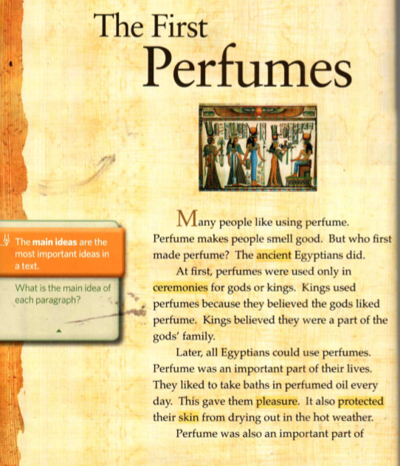

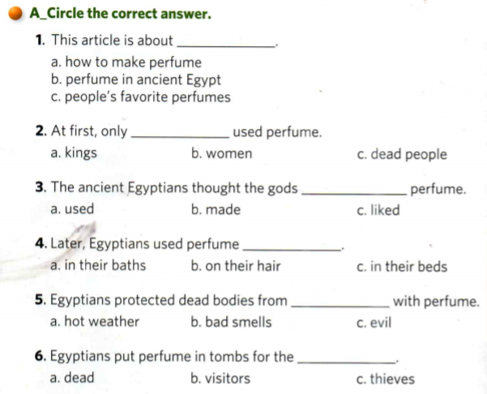
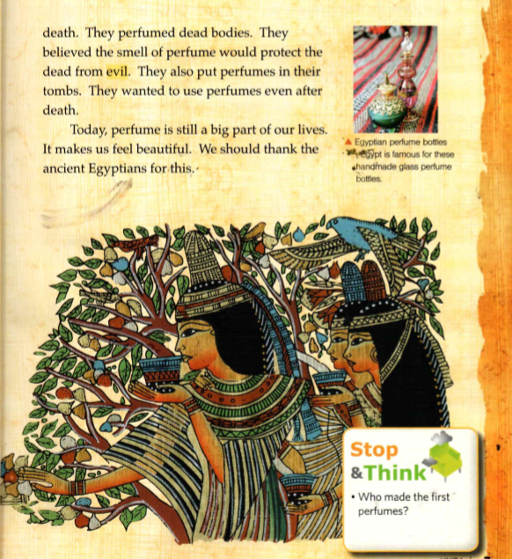

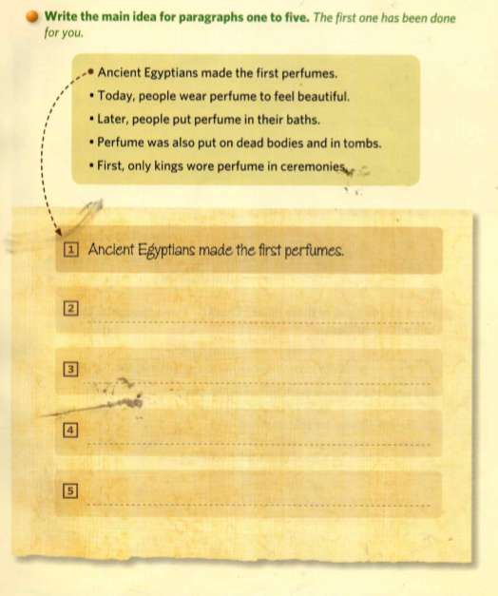

- Make and complete the chart with the words from the reading “The First Perfumes”. Look for pictures, meaning, and synonyms and write a sentence with each word. The words are perfume, smell, ancient, Egyptian, ceremony, part, important, take a bath, perfumed, pleasure, protect, skin, dry out, weather, death, dead, evil, tomb, believe and king.
WORD | PICTURE | MEANING | SYNONYMS | SENTENCE
Perfume | 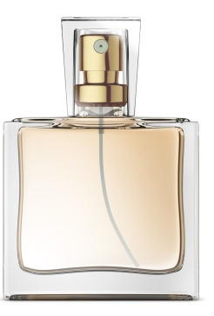 | A liquid with a pleasant smell, usually made from oils taken from flowers or spices and often used on the skin. | scent | She adores French perfume.

Note:
Print out and submit this module when we get back to class.

