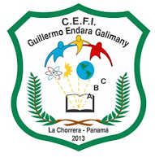
Ministry of Education
English Department
C.E. Guillermo Endara Galimnay
Review Module

Student: ___________________________________ Level: 6° ______ year: 2020
Teacher: Cristhian Serrano Q.

1. INSTRUCTION: OBSERVE THE INFORMATION IN THE SQUARE AND COMPLETE THE MAP. WRITE THE CORRECT OPTIONS THAT BELONG TO LITERATURE.

1. Camera 2. Poetry/Poem 3. Pencil case 4. Short story 5. School 6. Legends 7. Parks

8. Fiction 9. students 10. Non-fiction 11. Saturday 12. Fables 13. houses 14. Tales.

Literature

2. INSTRUCTION: READ THE DEFINITION OR SENTENCES THEN COPY THEM NEXT TO THE CORRECT LITERARY ELEMENTS.
1. It refers to the problem in the Reading. 2. It refers to the place where the event happens.

3. It refers to peolpe, animals sor things performing in the reading. 4. It is the person who writes the story.

5. It means the series of events: first, next, etc. 6. It is the name of the story

7. it is the conclusion of the reading

Plot: ____________________________________________________________________________________

Setting: __________________________________________________________________________________

Chararcters: ______________________________________________________________________________

Title: ____________________________________________________________________________________

Conflict: ________________________________________________________________________________

Autor: ___________________________________________________________________________________

Resolution: ______________________________________________________________________________

3. OBSERVE THE TREE AND WRITE THE PARTS IN SINGULAR AND PLURAL

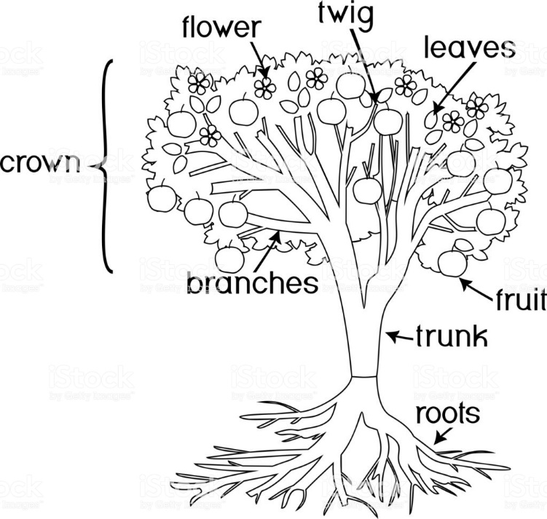
LEAF

BRANCH

MESSAGE FROM THE TEACHER:

Protect yourself and your family: wash your hands with water and soap. Don´t touch your face, eyes, and mouth. Avoid physical contact with other. Say hello from a distance of 1 meter.

Soap: jabón avoid: evitar

Ministry of Education
English Department
C.E. Guillermo Endara Galimnay
Review Module (N.E.E)

Student: ___________________________________ Level: 6° ______ year: 2020
Teacher: Cristhian Serrano Q.

1. INSTRUCTION: COMPLETE THE MAP. WRITE THE CORRECT OPTIONS THAT BELONG TO LITERATURE.
(Escoger 7 palabras que pertenezcan a literatura y con eso completa el mapa)

1. Camera 2. Poem 3. Pencil case 4. Story 5. School 6. Legends 7. Parks

8. Fiction 9. students 10. Non-fiction 11. Saturday 12. Fables 13. houses 14. Tales.

Literature

2. INSTRUCTION: READ THE DEFINITION OR SENTENCES THEN COPY NEXT TO THEM THE CORRECT LITERARY ELEMENTS. (Copie la palabra a lado de su definición correcta)

TITLE PLOT RESOLUTION SETTING CHARACTERS CONFLICT AUTHOR

1. ___________________________: It refers to the problem in the Reading.

2. ___________________________: It refers to the place where the event happens.

3. ___________________________: It refers to peolpe, animals sor things performing in the reading.

4. ___________________________: It is the person who writes the story.

5. ___________________________: It means the series of events: first, next, etc.

6. ___________________________: It is the name of the story

7. ___________________________: it is the conclusion of the reading

3. OBSERVE THE TREE AND WRITE THE PARTS IN SINGULAR AND PLURAL. SEE THE OPTIONS
N.E.E
(Identifique las partes del árbol y escriba la palabra en singular y plural, vean las opciones)

1. root / roots 2. branch / branches 3. trunk / trunks 4. leaf / leaves

5. fruit / fruits 6. flower / fowers

LEAF

MESSAGE FROM THE TEACHER:

Protect yourself and your family: wash your hands with water and soap. Don´t touch your face, eyes, and mouth. Avoid physical contact with other. Say hello from a distance of 1 meter.

Soap: jabón avoid: evitar

