CENTRO EDUCATIVO GUILLERMO ENDARA GALIMANY
ENGLISH MODULE
GRAMMAR, SCIENCE AND LITERATURE
I TRIMESTER

Student: _________________________ Level: ___3th_____
Date: ____________________________ Grade: __________

Objective:
- To practice the English language through different activities and Can understand the vocabulary as a main tool of English comprehension.
Teacher: Alcides Araúz
Topics | Learning Achievement
- The Personal Pronouns  - The parts of the plants  - Wild Animals  - Courtesy Forms | - Acquires new vocabulary and illustrate it  - Comprehends the meaning of the new words  - Identify the parts of the plants  - Identify the meaning of the personal pronouns.

Evaluation Criteria:

- Originality and creativity to develop the activities.
- Neatness and spelling.
Activity 1, (GRAMMAR):
Topic: The Personal Pronouns

Instruction:
- Learn the meaning in Spanish of the personal pronouns and illustrate them.
THE PERSONAL PRONOUNS | Spanish Equivalent
- I | YO
- YOU | TU
- WE | NOSOTROS
- THEY | ELLOS O ELLAS
- HE | EL
- SHE | ELLA
- IT | ESTO O ESTA ( PARA COSA O ANIMAL )

Activity 1: Illustrate the personal pronouns below.
Example:
SHE
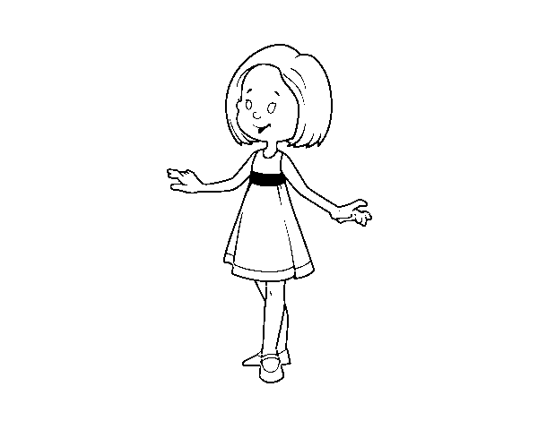
Activity 2, (SCIENCE):
Instruction: Learn the name of the parts of the plants.
Note: The students can draw a plant, and can practice putting the name of the plant in the correct position.

THE PARTS OF THE PLANT
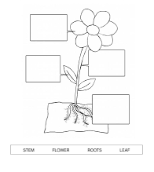
Roots Flower Stem Leaf
Roots
stem

Leaf
Flower

Activity 3 (WILD ANIMALS): Learn in English and Spanish the name of some wild animals and illustrate them.
English Word | Spanish Equivalent
- Peacock | Pavo Real
- Squirrel | Ardilla
- Snake | Serpiente
- Eagle | Águila
- seal | Foca
- Parrot | Loro
- Gorilla | Gorilla
- Camel | Camello
- Monkey | Mono
- Zebra | Cebra

Illustrate the wild animals as shown below.
Example:
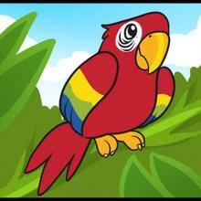
PARROT: LORO

Activity 4, (Literature): Illustrate the following words to understand the meaning in Spanish.
English Word | Spanish Equivalent
- Characters | Personajes
- Setting | Lugar
- Problem | Problema o asunto
- Solution | Solución

Example:
CHARACTERS: PERSONAJES

