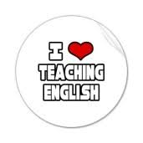
MINISTERIO DE EDUCACION
CENTRO EDUCATIVO GUILLERMO ENDARA GALIMANY
ENGLISH DEPARTMENT
STUDY GUIDE
LITERATURE - 12°

MISS REBECA CASTAÑEDA Date: Friday March 13th, 2020
OBJECTIVES: SWBAT understand and identify elements of literature (plot, setting, character, point of view, theme ).

- Glosary: students have to prepare a glossary using the elements of literature given by the professor. This glosary includes: definitions, example, pictures.

- Use color papers and a creative way to prepare this glossary.
- Make this glosary in your notebook.
- The examples of each element can be from the story that you prefer.

Evaluation: 15 points (3 points each element)
This will be evaluated when we get back to class.

- Literary Analysis: read the short story “Jack and the beanstalk” attached, then point out the following elements in your notebook.

- Plot
- Exposition
- Rising action
- Climax
- Falling action
- Resolution
- Conflict
- Setting
- Characters
- Point of view
- Theme

Evaluation: 10 points Due date: March 20th, 2020.
- Send your assignments back to my email rebeca.castaneda@meduca.edu.pa

Jack and the Beanstalk
Jack and the Beanstalk first appeared as The Story of Jack Spriggins and the Enchanted Bean in 1734. Featured iIllustrations are by Arthur Rackham, 1918 edition of English Fairy Tales retold by Flora Annie Steel.
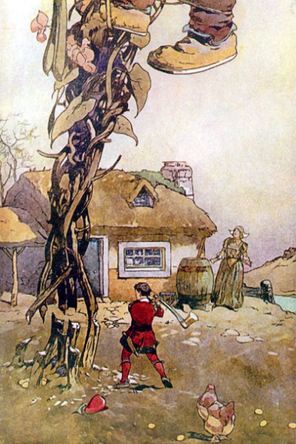
Once upon a time there lived a poor widow and her son Jack. One day, Jack’s mother told him to sell their only cow. Jack went to the market and on the way he met a man who wanted to buy his cow. Jack asked, “What will you give me in return for my cow?” The man answered, “I will give you five magic beans!” Jack took the magic beans and gave the man the cow. But when he reached home, Jack’s mother was very angry. She said, “You fool! He took away your cow and gave you some beans!” She threw the beans out of the window. Jack was very sad and went to sleep without dinner.
The next day, when Jack woke up in the morning and looked out of the window, he saw that a huge beanstalk had grown from his magic beans! He climbed up the beanstalk and reached a kingdom in the sky. There lived a giant and his wife. Jack went inside the house and found the giant’s wife in the kitchen. Jack said, “Could you please give me something to eat? I am so hungry!” The kind wife gave him bread and some milk.
While he was eating, the giant came home. The giant was very big and looked very fearsome. Jack was terrified and went and hid inside. The giant cried, “Fee-fi-fo-fum, I smell the blood of an Englishman. Be he alive, or be he dead, I’ll grind his bones to make my bread!” The wife said, “There is no boy in here!” So, the giant ate his food and then went to his room. He took out his sacks of gold coins, counted them and kept them aside. Then he went to sleep. In the night, Jack crept out of his hiding place, took one sack of gold coins and climbed down the beanstalk. At home, he gave the coins to his mother. His mother was very happy and they lived well for some time.

