MINISTRY OF EDUCATION
10 A-B CIENCIA Y COMERCIO
10 A-B CIENCIA Y COMERCIO
PANAMA WEST REGIONAL CENTER
CENTRO EDUCATIVO GUILLERMO ENDARA GALIMANY
ENGLISH DEPARTMENT

Elements of Literature

Grade: 11° A-B SCIENCE/ BUSINESS Literature

Melida I. Bravo

In this module, the students will learn to identify 5 elements of literature: Plot, Characters, Setting, Point of View and Theme.
Learning Objective: Students will be able to identify 5 elements of literature of fiction story.
Attachments:
- Class note of the 5 elements of literature (copied in the notebook)
- Copy of the “ The Architect’s plan¨
- Copy of literary elements

ASSIGNMENT:
- Read “ The Architect’s plan¨
- Identify the elements of the reading (use the copy to write the elements).
- Glossary 1 (5 Element of Literature)
- Glossary 2 ( The Architect’s plan key words in bold )
- Study the 5 Elements of Literature for future test.
Glossary:
- Look up meaning, the pronunciation and write sentences.
- Decorate the glossary 1 and 2 with a drawing related to the topic.

- THE ONLY SUMMATIVE ASSIGNMENT IS THE GLOSSARIES.

Elements of Literature

I. Plot - series of related events that make up a story

Five Stages of Plot

Exposition- introduces the setting, characters and the conflict

Complication or Rising Action - mini-conflicts that become more intense and builds as the main characters struggle to resolve their problems

Climax - turning point of the story; emotional high point (for the character, not the reader)

Falling action - events that lead to resolution

Resolution - outcome of the conflict; ties up most loose ends

Conflict - struggle between opposing forces within the plot

Man vs. man - external struggle between two or more individuals

Man vs. himself - internal struggle concerning emotion and decision

Man vs. nature - external struggle between man and an element of nature

II. Character -the entities involved in the action of the story

Character Types

Protagonist - the hero of the story who is faced with a conflict

Antagonist- the person or thing that causes the conflict

Dynamic (Round)- person who changes in personality or attitude

Static (Flat)- person who does not change

Stock Characters- easily recognized minor characters such as “wicked” step-mother type

Characterization - techniques the writer uses to develop character

Physical description

Speech and actions of the character

Direct comment from the narrator

What other characters say/do

III. Setting - the time and place where the action occurs

Time and Place

Time- the “when” of the story (date, day, time of day, season, etc.)

Place- the “where” of the story (city, town, state, country, house, room, etc.)

IV. Point of View- perspective from which a story is told

Third Person Omniscient- narrator knows all the thoughts, motives and feelings of each character

Third Person Limited - narrator stands outside the action and focuses on one character’s thoughts, feelings and observations.

First Person- main character tells his own story and refers to himself as “I”.

Objective- Narrator does not tell the thoughts or feelings of anyone, so only action and words are reported

V. Theme- The main idea or basic meaning of a literary work

Symbol- a person, place or object that has a concrete meaning in itself and also stands for something beyond itself, such as an idea or feeling.

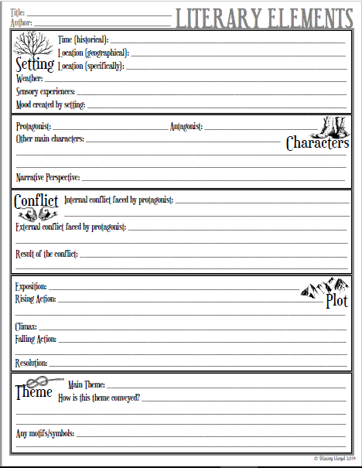
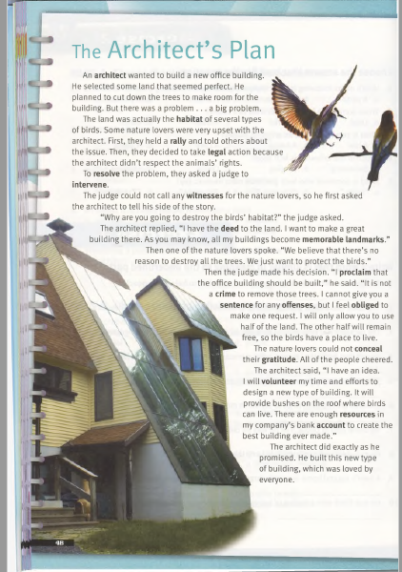

GLOSSARY RUBRIC
Name: ________________________ Date: ______________ Level: _______
Key words  Components are  In bold | Always  20 pts | Often  15 points | Sometimes  10 points | Never  5 or 0 point (s) | TOTALS
Definitions | The definition is correct, accurate | The definition is correct but may have inaccuracies | The definitions is missing one or two key components | The definition is incorrect, inaccurate.
Sentences | The sentences are in your own words and related to all of the words that were defined. | The sentences are in your own words and may relate to the words that were defined. | The sentences are in your own words and may relate to some of the words that were defined. | The sentences are not in your own words and may relate to any of the words that were defined.
Drawing | The drawing is neat, colorful, creative, and relate to the story. | Most of the drawing is neat, colorful, creative, and relate to the story. | Some of the drawing is neat colorful, creative, and related to the story. | The drawing is not neat, colorful, creative, and related to the story.
Spelling, Punctuation, and Grammar | The definitions and sentences have zero to one error. | The definitions and sentences have two or three errors. | The definitions and sentences have four or five errors. | The definitions and sentences have many errors.
Organization, Neatness, and Completeness | The glossary is organized by unit, labeled | The glossary is missing one of the three components. | The glossary is missing two of the key components. | The glossary is missing all key components
Grand Total |  |  |  |  | Final  Grade

